Dis-Eur-Vinca-Figurine-**138mm**

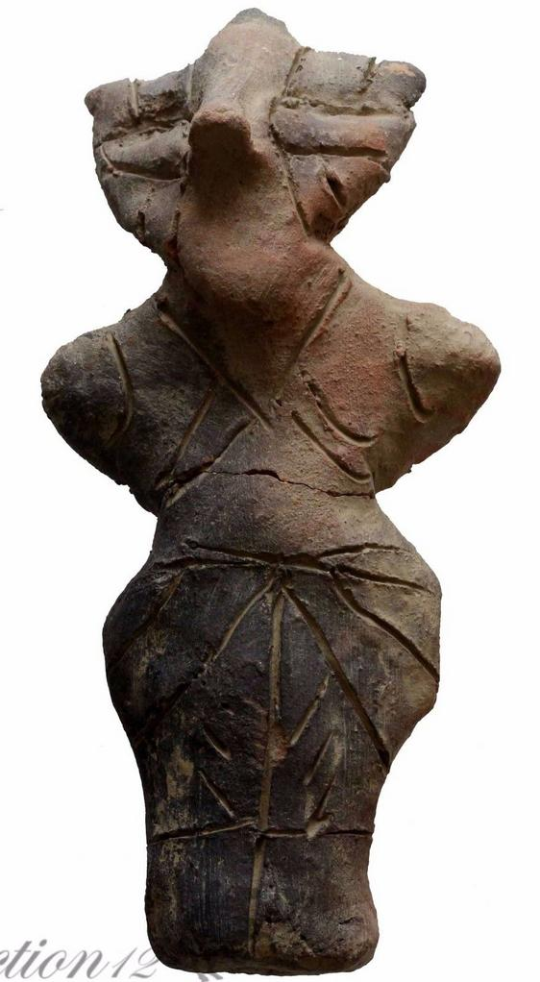 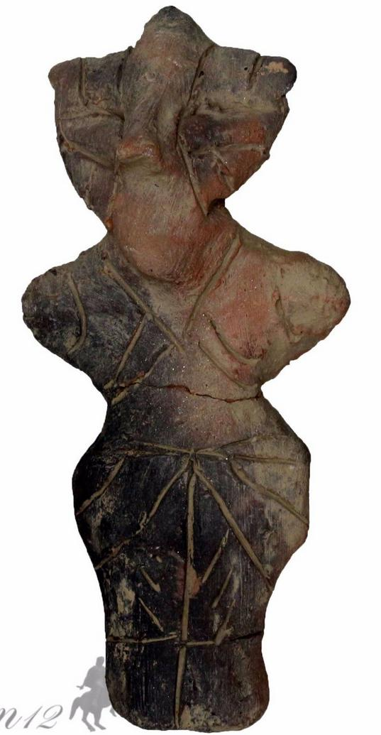 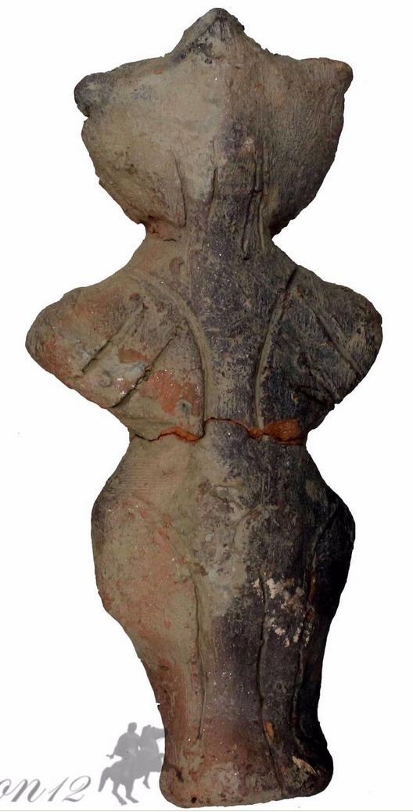

**138mm x 64mm x 40mm**

162 gm

Formal Label:

Accession Number:

Date or Time Horizon:

Geographical Area:

Cultural Affiliation:

Media:

Dimensions:

Weight:

Condition:

Provenance:

**References:**

**Discussion:**

Sold by [coinauction12](http://myworld.ebay.com/coinauction12) ( [7393](http://feedback.ebay.com/ws/eBayISAPI.dll?ViewFeedback&userid=coinauction12) )

Estimated delivery Thursday, Dec 15, 2016 - Wednesday, Dec 21, 2016

#### [PREHISTORIC ANTHROPOMORPHIC FIGURE STATUE VINCA 4500-3500 BC](http://www.ebay.com/itm/201736541145)

|  |  |
| --- | --- |
| Item price | $121.78 |
| Quantity | 1 |
| Item number | 201736541145 |
| Shipping service | Royal Mail International Signed |

## Shipping address

Ralph J Coffman Jr

149 Atlantic Ave

Swampscott MA 01907-2427

United States

## Order total

|  |  |
| --- | --- |
| Subtotal | $121.78 |
| Shipping | $17.56 |

**Total**

$139.34